**#1. Basic of C Programming**

**Roll Number:**

**Date of Submission:**

**Aim:**

Write C program to for the following requirements:

1. Prompt two numbers from user along with the option of arithmetic operation. Use appropriate data type to print the results. Run the program continuously until the user chooses an option for exit.

[Note: Use conditional and looping statements]

1. Prompt 5 numbers from user and store it in an array. Print each value and their category as even/odd number using a pointer. Finally sort the array in ascending order and display the output.

[Note: Use pointers, conditional and looping statements]

1. Perform the above operation using user defined functions.

**Tools Required:**

Text editor with C Compiler.

**Experiment:**

**i)**

Code

#include <stdio.h>

#include <stdlib.h>

// Do Arithmetic Operations for two numbers till the user exits

int main() {

int running = 1;

while (running)

{

// switch variable

char var = '+';

printf("\nAddition - (+)\nSubtraction - (-)\nMultiplication - (*)\nDivision - (/)\nExit - (x)\n"); // Explaining the Operations

printf("Enter the Operation You Want to do : ");

scanf(" %c", &var); // getting the operator with a space to ignore preceding whitespace

//printf("%c",var);

if (var != 'x')

{

float x, y;

printf("Enter the first number: ");

scanf("%f", &x); // getting the 1st number

printf("Enter the second number (for division don't give zero): ");

scanf("%f", &y); // getting the second number

// switch statement

switch (var)

{

case '+': // doing the addition operation

printf("\nAddition Operation.\n");

printf("Addition of numbers is: %f", x + y); // print the result

break;

case '-': // doing the subtraction operation

printf("\nSubtraction Operation.\n");

printf("Subtraction of numbers is: %f", x - y); // print the result

break;

case '*': // doing the multiplication operation

printf("\nMultiplication Operation.\n");

printf("Multiplication of numbers is: %f", x * y); // print the result

break;

case '/': // doing the division operation

printf("\nDivision Operation.\n");

if (y == 0) {

printf("Division by zero is not possible.");

} else {

printf("Division of numbers is: %f", x / y); // print the result

}

break;

default:

printf("Invalid operation. Please try again.");

break;

}

continue;

}

else

{

running = 0;

continue; // exit the loop

}

}

return 0;

}

Flow Chart

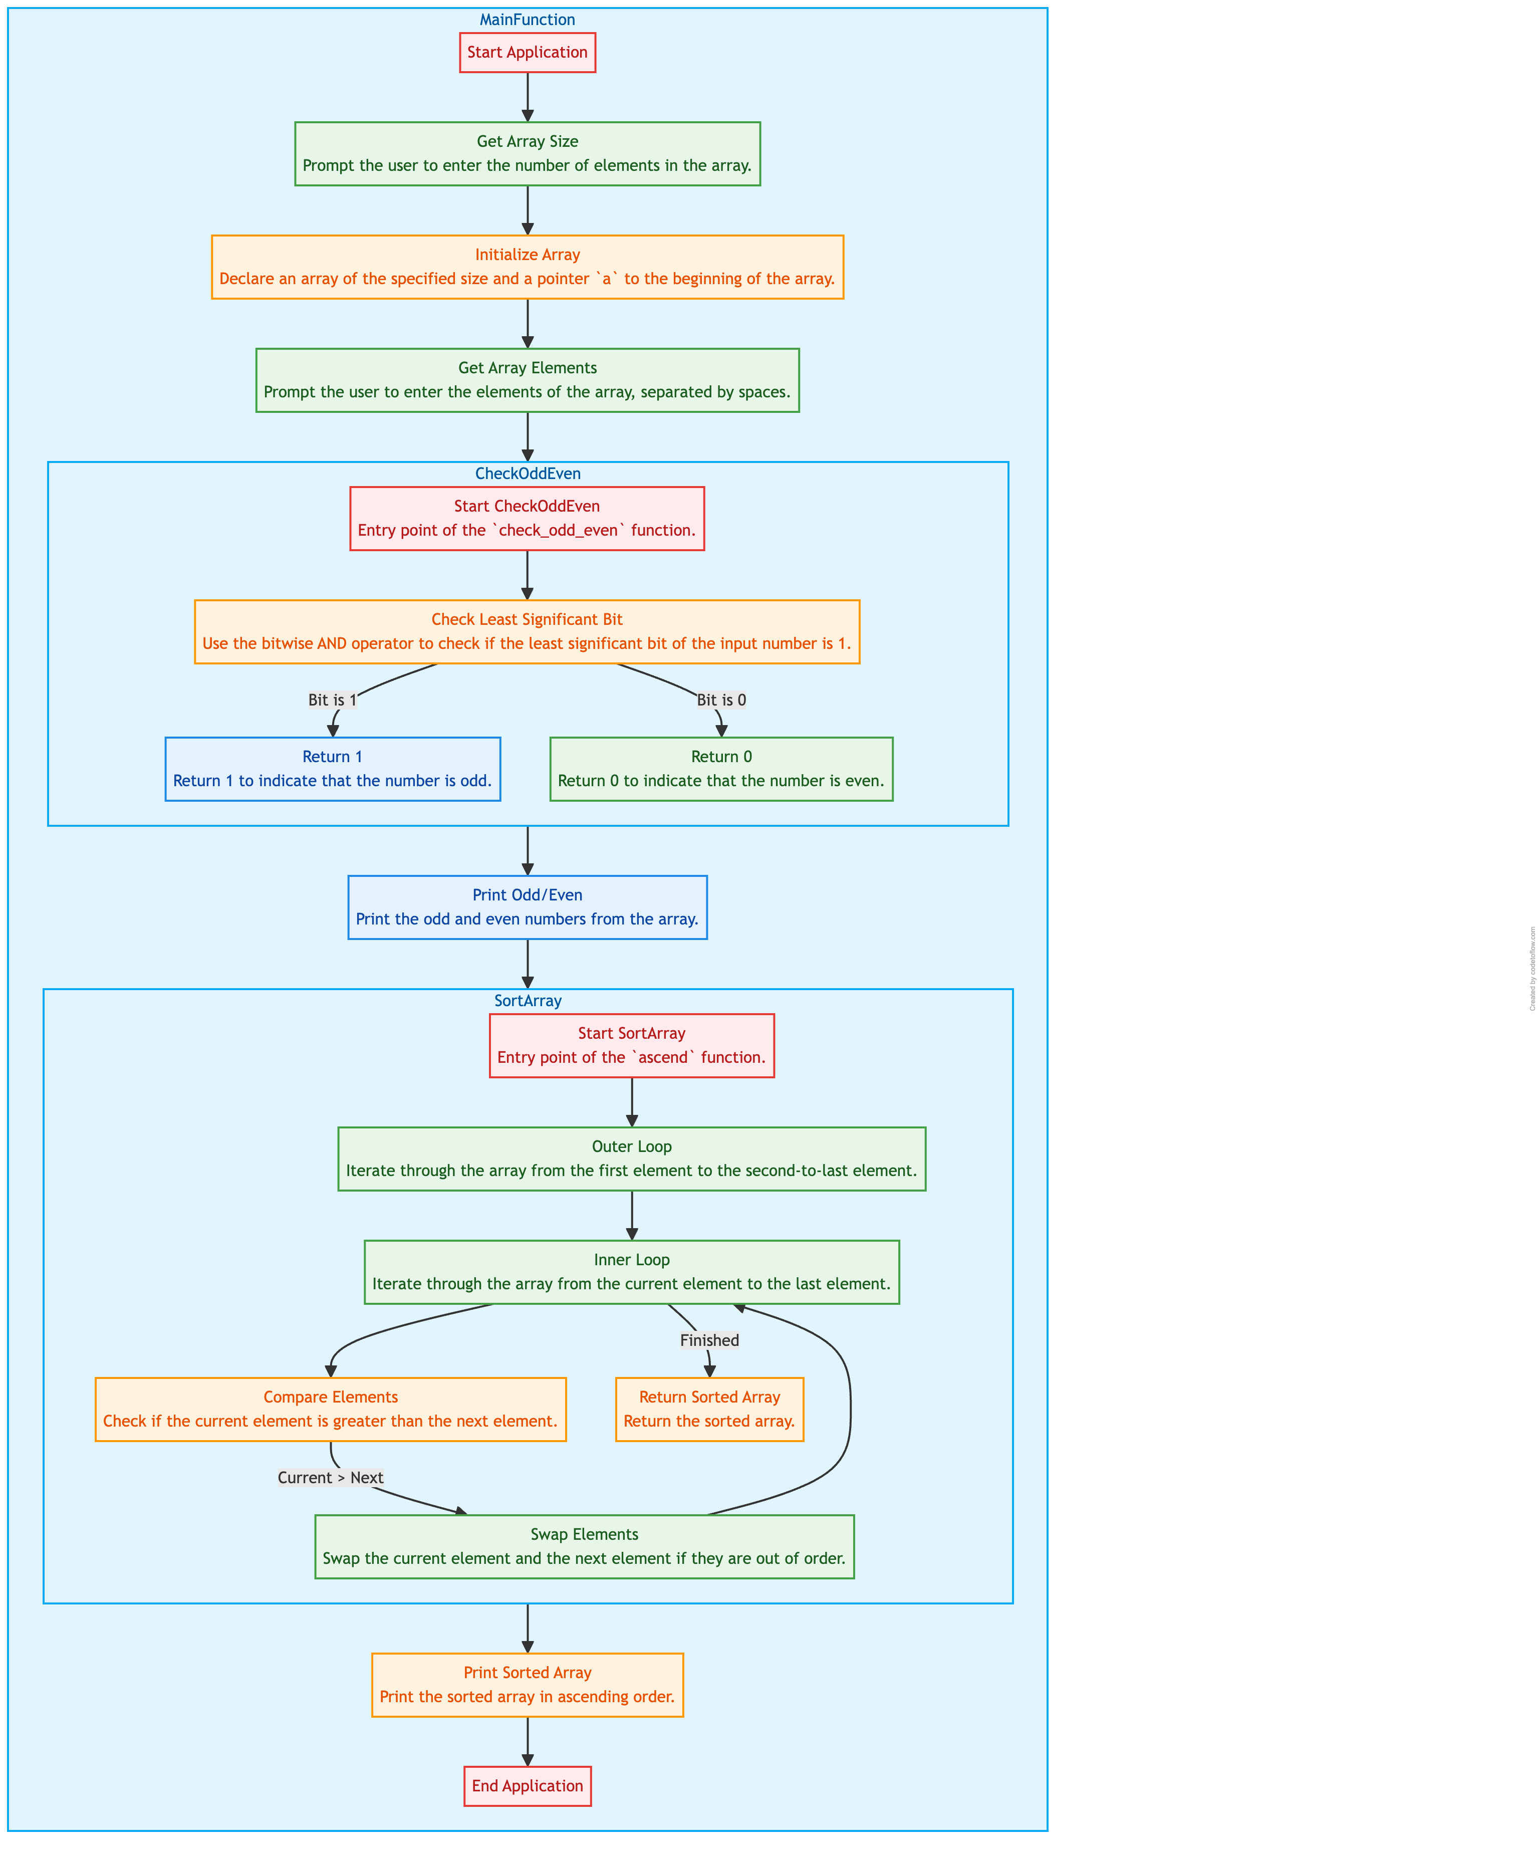

Result

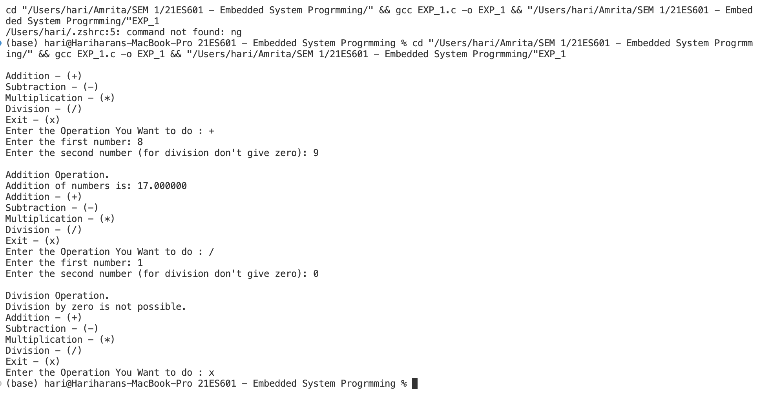

**ii)**

Code

// Question 2

#include <stdio.h>

#include <stdlib.h>

int main() {

int num;

// Ask the user for the number of elements in the array

printf("No of elements in array: ");

scanf("%d", &num);

// Declare an array of size 'num'

int arr[num];

// Declare a pointer 'a' and point it to the beginning of the array

int *a = arr;

// Ask the user to enter the elements of the array separated by spaces

printf("Enter elements of array with space: ");

for (int i = 0; i < num; i++) {

scanf("%d", (a + i));

}

// Loop through the array to determine if each element is odd or even

for (int i = 0; i < num; i++) {

if (*(a + i) & 1) {

printf("\nOdd number : %d", *(a + i));

} else {

printf("\nEven number : %d", *(a + i));

}

}

// Sort the array in ascending order using bubble sort

for (int i = 0; i < num - 1; i++) {

for (int j = i + 1; j < num; j++) {

if (*(a + i) > *(a + j)) {

// Swap the elements if they are out of order

*(a+i) = *(a+i) + *(a+j);

*(a + j) = *(a+i) - *(a + j);

*(a + i) = *(a+i) - *(a + j);

}

}

}

// Print the sorted array in ascending order

printf("\nAscending Order");

for (int i = 0; i < num; i++) {

printf(" -> %d", *(a++));

}

return 0;

}

Flow Chart

Result

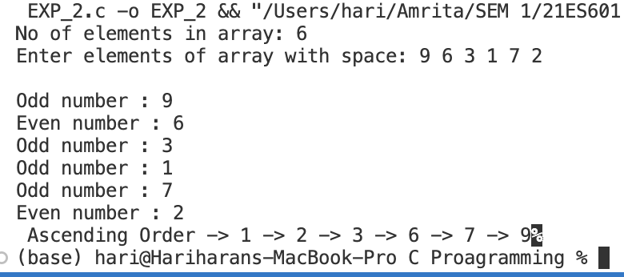

**iii)**

**Code**

// Question 3

#include <stdio.h>

#include <stdlib.h>

// Function to check if a number is odd or even

int check_odd_even(int* a) {

if (*(a) & 1) {

return 1; // Return 1 if the number is odd

} else {

return 0; // Return 0 if the number is even

}

}

// Function to sort an array in ascending order using bubble sort

int* ascend(int* a, int num) {

for (int i = 0; i < num - 1; i++) {

for (int j = i + 1; j < num; j++) {

if (*(a + i) > *(a + j)) {

// Swap the elements if they are out of order

*(a + i) = *(a+i) + *(a+j);

*(a + j) = *(a+i) - *(a + j);

*(a + i) = *(a+i) - *(a + j);

}

}

}

return a; // Return the sorted array

}

int main() {

int num;

// Ask the user for the number of elements in the array

printf("No of elements in array: ");

scanf("%d", &num);

// Declare an array of size 'num'

int arr[num];

// Declare a pointer 'a' and point it to the beginning of the array

int *a = arr;

// Ask the user to enter the elements of the array separated by spaces

printf("Enter elements of array with space: ");

for (int i = 0; i < num; i++) {

scanf("%d", (a + i));

}

// Loop through the array to determine if each element is odd or even

for (int i = 0; i < num; i++) {

if (check_odd_even((a + i))) {

printf("\nOdd number : %d", *(a + i));

} else {

printf("\nEven number : %d", *(a + i));

}

}

// Sort the array in ascending order

int *ascending_arr = ascend(arr, num);

// Print the sorted array in ascending order

printf("\nAscending Order");

for (int i = 0; i < num; i++) {

printf(" -> %d", *(ascending_arr++));

}

return 0;

}

**Flow Chart**

**Result**

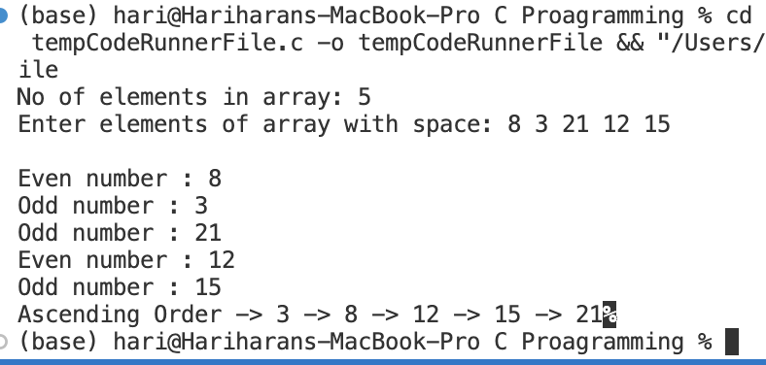

**Inference and Result:**